PLANETARY HEALTH TRANSECT
Route Briefing for Participants

Kathmandu → Chitwan → Pokhara → Lower Mustang (Marpha) → Upper Mustang
This briefing is designed to help participants understand what they will observe while traveling each stretch of the transect. Read the relevant section before departure or during travel. Each section covers what to expect in terms of geography, geology, ecology, climate, settlements, culture, and land use.
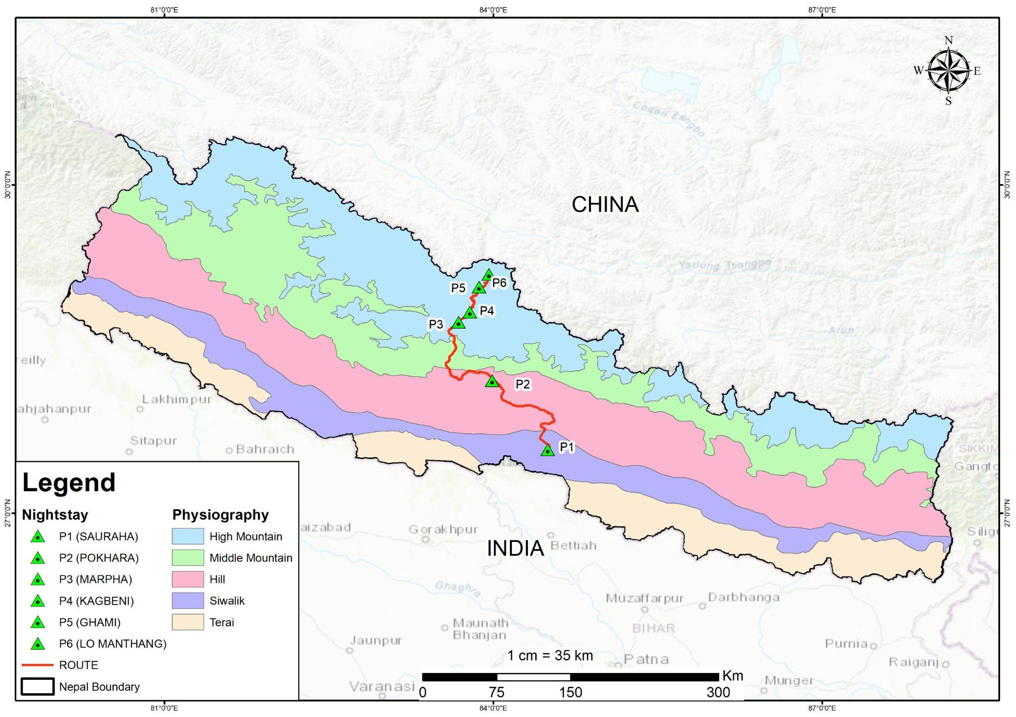

Stretch 1 | Kathmandu to Chitwan

Landscape & Geography

Starting Point: Kathmandu Valley
Kathmandu is located in the Midlands (Mid-Hills). The landscape is characterised by a broad, fertile valley floor surrounded by steep hills. The geology of this region consists of sediment-filled basins that have historically supported dense settlements and intensive agriculture.

Transition: Siwalik Hills
As you move south toward Chitwan, the route crosses the Siwalik Hills, also known as the Churia Range. Historically, this area was known as "Tharwot" and comprises southern forested areas that stretch across the northern edge of the Terai.

Destination: Chitwan District
Chitwan lies within the Inner Terai, which consists of broad, low-lying longitudinal valleys such as the Rapti Valley. While the region was once covered in dense, virgin forest, much of it has been converted into fertile agricultural land over the last several decades. You will experience a transition from hilly terrain to a flat, tropical landscape dominated by fields of rice, mustard, and maize.

The Mugling Road
Traveling along the Mugling road involves a descent from the Nagdhunga Pass (1,500 m) to the low-lying Mugling Bazaar (265 m), following the Mahesh Khola and Trishuli River valleys.
- Geographical and Topographical Views: The landscape transitions from steep hilly terrain between Nagdhunga and Naubise (representing about 13% of the route) to broad longitudinal river valleys for the remaining 87%. The road is characterised by sharp bends, curved alignments, and narrow intersections as it follows the left bank of the Trishuli River.
- Geological Features: The route passes through the Mahabharat Range, belonging to the Lesser Himalaya. You will see rock sequences of weathered phyllite, metasandstone, quartzite, limestone, and dolomite. Soil types vary from residual and colluvial deposits on the hillsides to alluvial deposits (up to 15 m thick) along the riverbanks.
- Ecological Views: The vegetation shifts from Schima-Castanopsis and Pine forests near Kathmandu to Hill Sal and Riverine Khair-Sissoo forests as you approach the subtropical zones of Chitwan.

Slopes & Landslide Hazard
This road is notorious for its high landslide susceptibility due to geologically young, unstable landscapes and intensive monsoon rainfall. Major active mass movements are visible at Krishnabhir (Km 58) and Jogimara (Km 64), where rocks are highly fractured and frequently sheared. The Jogimara section is specifically noted as a potential rockfall zone.
What to Observe: Look at the slopes along the road — do you see netting, concrete barriers, or freshly exposed earth? These are attempts to hold back hillsides that have a history of collapsing, especially after heavy rain. Notice how the trees change as you descend: the forests near Kathmandu look different from the ones closer to Chitwan. What differences can you spot in colour, density, and leaf size?

Climate
Traveling this route takes you from a Warm Temperate zone in Kathmandu to a Subtropical zone in Chitwan.
- Kathmandu: Has a more moderate, temperate climate due to its higher elevation.
- Chitwan: Experiences a subtropical climate characterised by higher humidity and heat. During the monsoon (June–September), temperatures can reach up to 33°C. In winter, temperatures typically range between 7°C and 23°C.
- Precipitation: Both regions are heavily influenced by the summer monsoon, which accounts for 80% of annual rainfall. The Terai plains of Chitwan often experience higher overall humidity and tropical weather patterns.

At-a-Glance Summary
Feature | Kathmandu (Midlands) | Chitwan (Inner Terai)
Altitude / Physiography | Hilly Midlands; fertile valley floor | Flat, low-lying longitudinal valley
Climate Zone | Warm Temperate | Subtropical
Primary Vegetation | Temperate mixed forests (historically) | Subtropical Sal forests and grasslands
Typical Temperature | Cooler / Moderate | Hot and Humid (up to 33°C in summer)

